Introduction

This JCreator project An account program that allows 5 users to be input into the system, it also each user to process an overdraft
The program itself utilizes IF Statements, Methods, While/for loops return commands, Constructors, Polymorphism, inheritance and extends
Once the input from 1 to 5 from the menu is entered e.g Lodge, it will pass the users input to a different classes outside the main one that will execute the command and then if needed, returns the input value to the main method itself.

Through this program the user may;
- Lodge
- Withdraw
- View customer details
- Log in as a different customer
- Quit program
After all this the program will safe to a word document containing all the accounts

I’ll go through 5 Areas in the Documentation
- Introduction
- Steps
- Program walkthrough
- Test bed
- Conclusion/Evaluation

Steps for main test
- Allow inputs
- Global Variables
- Declare main variables
- Secondary variables
- While loop to take in customers
- Begin login while loop
- Start do
- Case:1 Lodge
- Case:2 Withdraw
- Case:3 View customers
- Case:4 Sign in different account
- Case:5 Quit
- Save to a file
- End main method
- End class

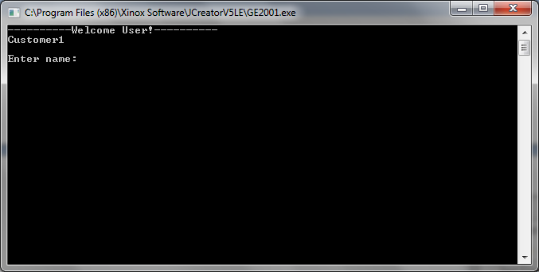
This is the program introduction

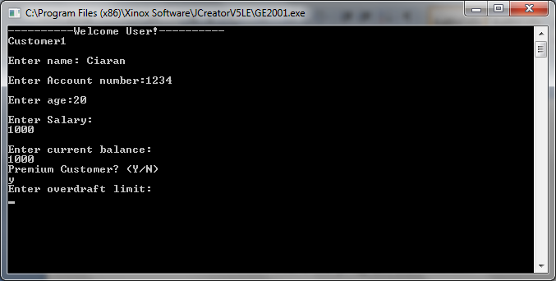
As shown above, the program will take all the necessary information for the customers, each of the inputs are error checked for mistakes As I'll show in the next slide for customer 2.
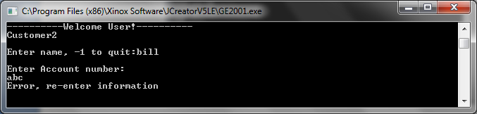
As you can see, Account number input will not allow for input of text, this is done by sending the input down to the Validate. Class method for validation, all inputs are send to this class.

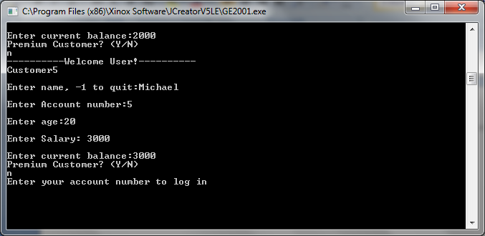
Once the max of 5 users has been entered, The program will ask the user the enter an account number that corresponds to the user.
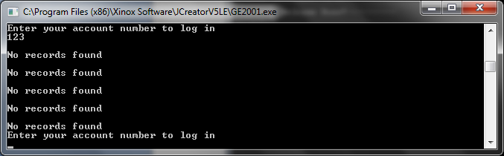
If you enter an account number that is not among the array, the program will check all accounts to try and make a match for the right one hence all the No records found been displayed.
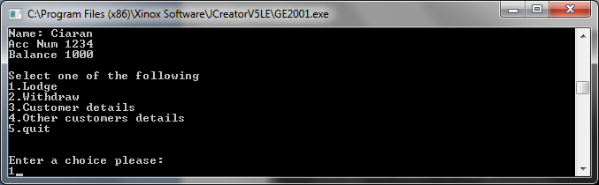

The menu will appear once a valid user is entered

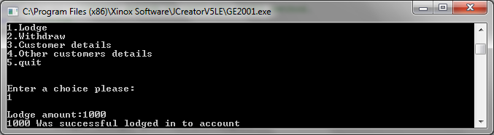

Lodge option places money inside the account of the user, Validation of course also take s place here.

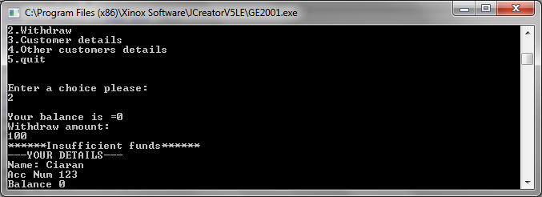
Withdrawing money could only be done with an overdraft, the result leaves you with a minus depth on you account

As shown here
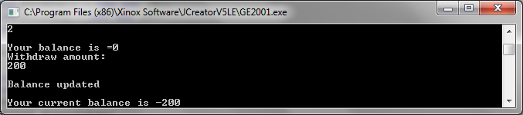

Of course view customer details display your info once selected
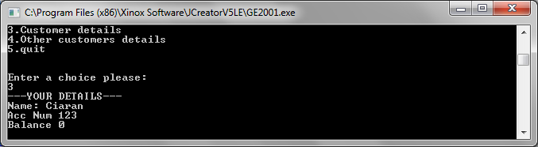

Choosing 4 allows you to alternate between different profile

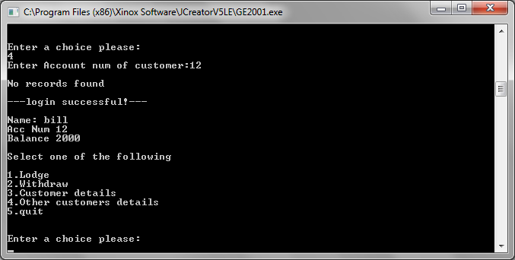
If 5 is choosing the program will quit, but before that it will prompt the user the save the accounts into a doc file, this save feature is a different class within the program called Save.java
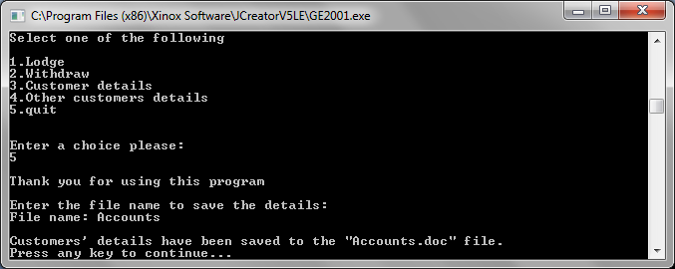
Test Bed
Scenario | Data Entered | Expected Result | Actual Result
Enter name | 1 | Name:1 | Name:1
Enter account number | R | Show error | Show error
En | 2 | Prompt Enter Customer Code | Prompt Enter Customer Code
Enter Age | Bi | Show error | Show error
Enter Salary | 1000 | 1000 | 1000
Enter Current balance | K | Show error | Show error
Premium customer y/n | 123 | Error | Disabled overdraft [N]
Enter overdraft [if Y was selected] | 100 | 100 | 100
Enter account num | 999 | No records found | No records found
Menu 1-5 | abc | Show error | Crash
Quit | 5 | Quit program, display save doc | Quit program, display save doc
Save as 000.doc | 000 | Details have not been saved | Details have not been saved
Save as accounts.doc | accounts | Details have been save | Details have been saved

Conclusion and evaluation

This program works efficiently after alterations were made to the coding.
The Test bed went fine except some minor issues with the program crashing some instances, the issues have since been resolved.
If I had more time or another opportunity, I would have created or improved my program vastly by
- Increasing data input such as student DOB, Address etc.
- Made the program have a repeat option for quick multiply use.

So many other things I’d do it would be too many lines for this page.
I’m quite pleased with the end result, I'm still quite confused as to the Withdraw and Lodge options malfunctioning, more annoying so because I believe it's a believe simple problem to address but I can't figure it out.
Overall I'd say to Program was well put together and the comments are quite descriptive.

